Problem​ ​Statement​ ​1:

You take the SAT and score 1100. The mean score for the SAT is 1026 and the standard

deviation is 209. How well did you score on the test compared to the average test taker?

Problem Solution:

Formula:

**z = (x – μ) / σ**

Solution:

Step 1:    
[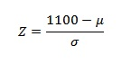](http://www.statisticshowto.com/wp-content/uploads/2013/08/CALCULATE-A-Z-SCORE-1.jpg)

Step 2: **Put the mean, μ, into the z-score equation**.  
[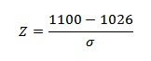](http://www.statisticshowto.com/wp-content/uploads/2013/08/CALCULATE-A-Z-SCORE-2.jpg)

Step 3: **standard deviation, σ into the z-score equation**.  
[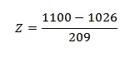](http://www.statisticshowto.com/wp-content/uploads/2013/08/CALCULATE-A-Z-SCORE-3.jpg)

Step 4:    
(1100 – 1026) / 209 = .354. This means that score was .354 std devs above the mean.